Set Up process for Heliflight-3d running on a Tiny Talon F7 Flight controller in a K120 helicopter. This is an F7 Flight controller that with 15A ESC’s for 2-4s. The ESC’s are BLHeli_32 which does Bi-directional D-shot for motor RPM telemetry natively.

<https://www.rcgroups.com/forums/showthread.php?3535457-Introducing-the-Heliflight-3D-(HF3D)-open-source-Helicopter-flight-controller-(FBL)>

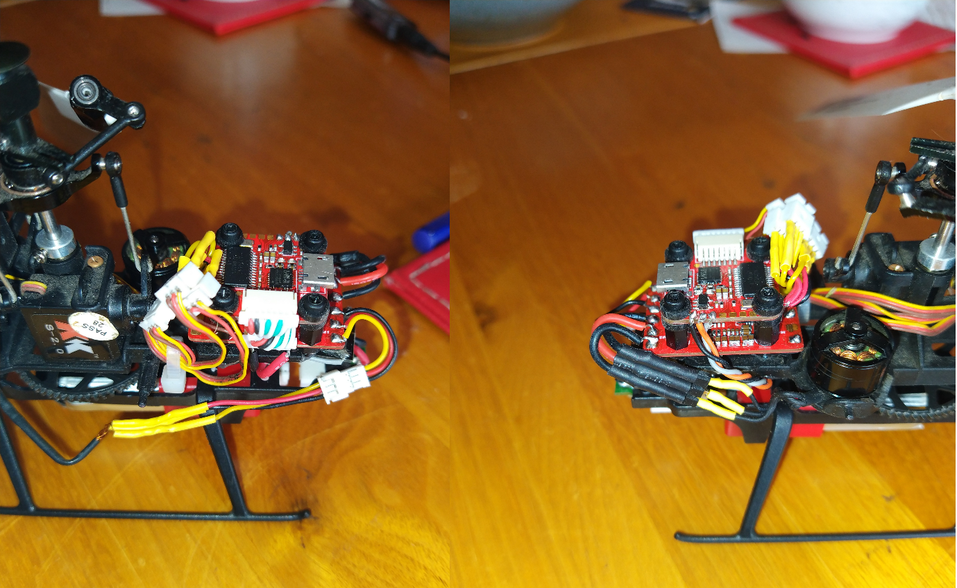

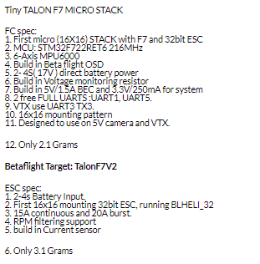

Servo Wiring.

I used 3 Micro JST 1.25 plug connectors to suit the k120 servos. The signal wires of these sockets are connected to the pins shown below. The 5v and GND for each socket are wired together and attached to the 5v and GND

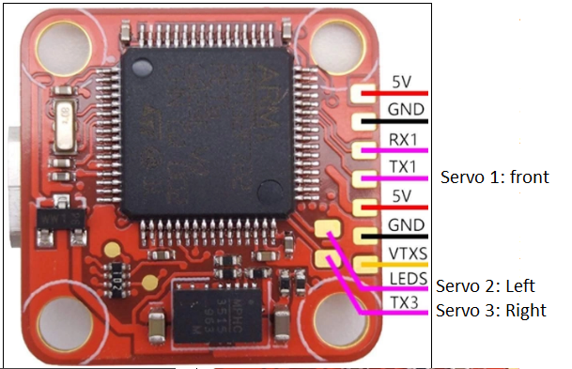

Motor wiring.

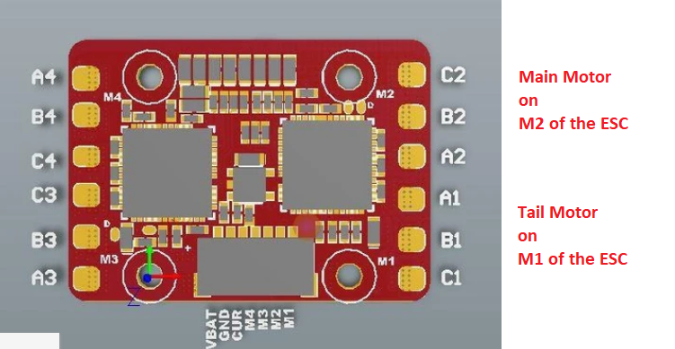

RX wiring.

I’m using an Sbus RX so I wired it to RX5 just as the manufacturer pics

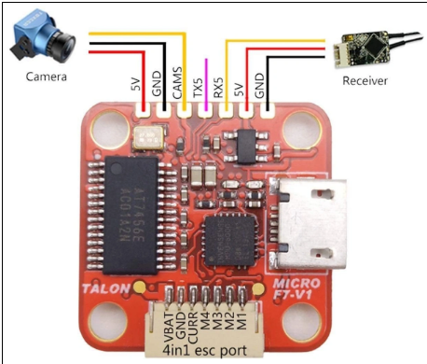

1. Download Betaflight. I’m using version 10.6.0
2. Open and select Update firmware



1. Load Firmware [LOCAL] and select the Hex file from the Zip files. Set the “Full Chip Erase”

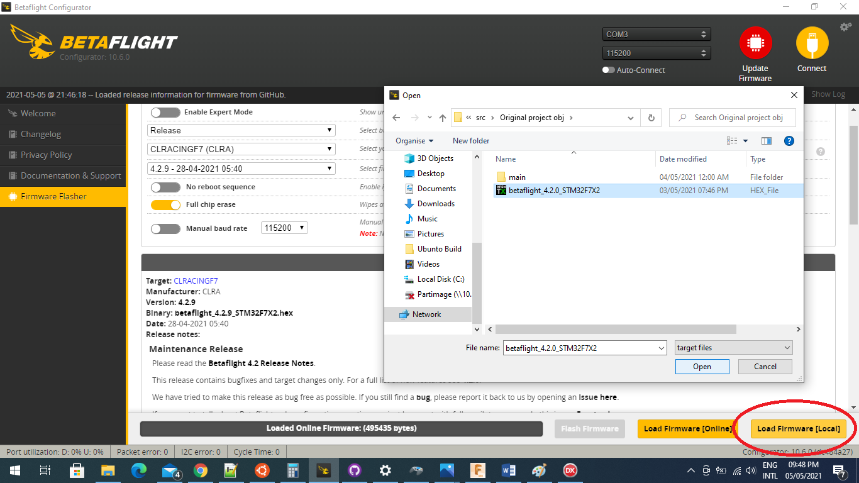

1. Wait for the Programming Successful and click “Connect”

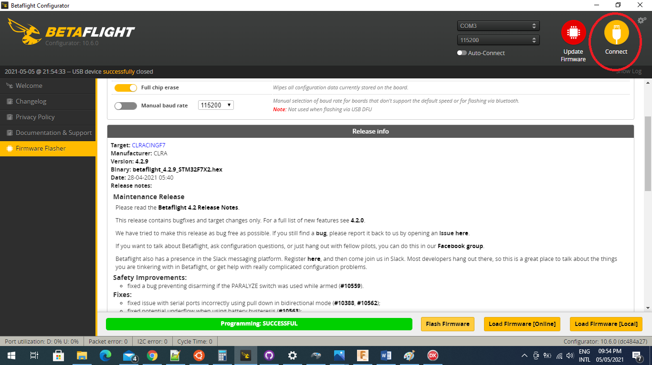

1. Apply custom defaults

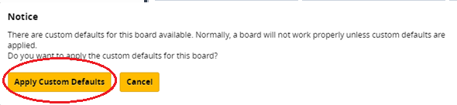

1. Reconnect and select CLI

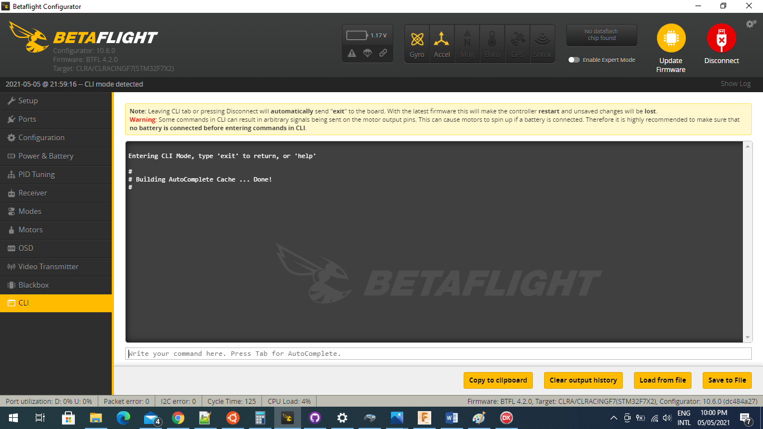

1. Open the K120_Dump.txt file. Select all of the text in the file (ctrl A) and copy (ctrl C).

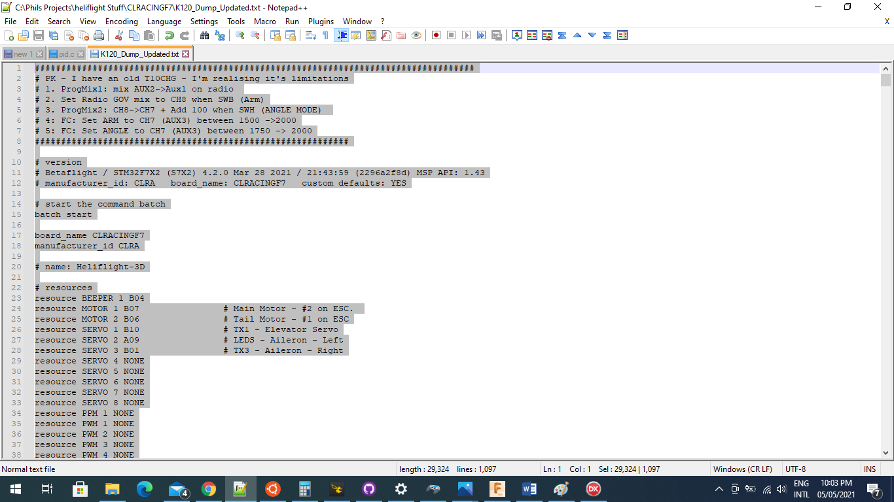

1. Past this into the Betaflight CLI and click ENTER. The settings will then be loaded.

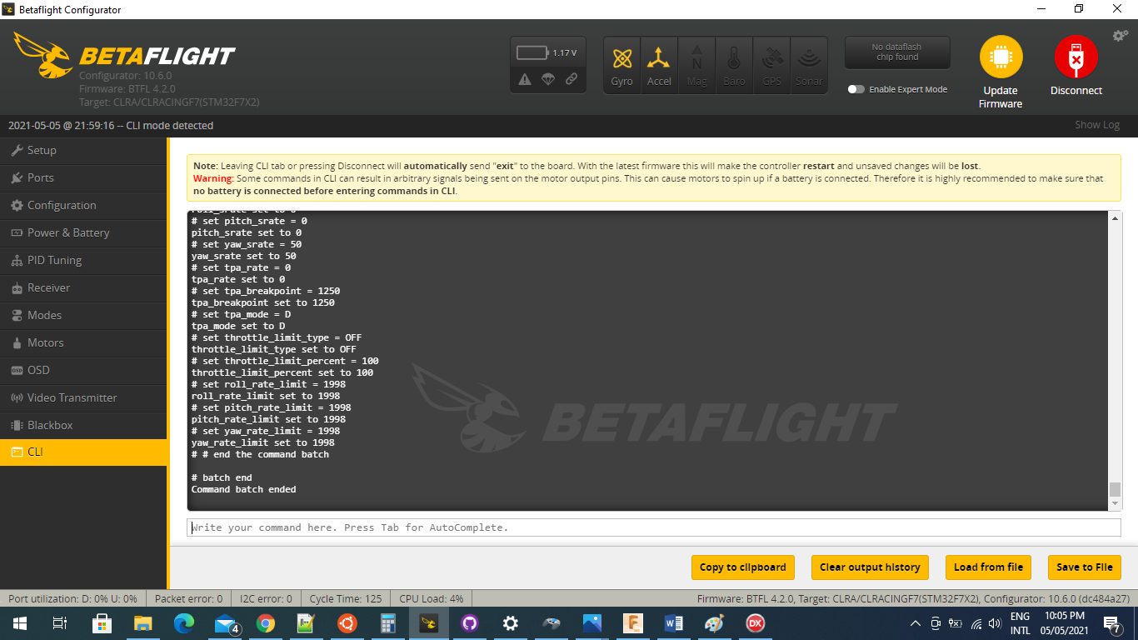

1. Type “save” in the CLI and push ENTER (really important. Config won’t be saved if you don’t save….)
2. Download BLheli_32 and open. Select CONNECT and Read Setup. It should discover 2 ESC’s (it needs to have a battery connected, not just USB).
3. Update BLheli if you need/want to
4. Select single ESC by clicking on the “2” under multiple ESC.

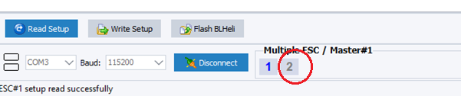

1. Select read setup from .ini file and select the BLHeli32_Main Motor.ini file from the Zip folder.

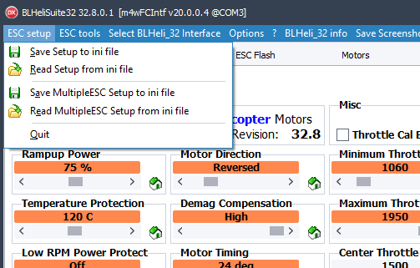

1. Write Setup to ESC
2. Select the second ESC (and deselect the first). Repeat and load the BLHeli32_Tail Motor.ini
3. Open Betaflight again and connect. In the Configuration tab select your receiver. Mine is SBUS so that’s what it will come up with.
4. Open the receiver tab and make sure your radio is set up to centres and operating correctly. The PITCH has to be on ch5. I have a FUTABA so pitch is natively CH6 so had to mix CH6 it to CH5. Your radio channel map needs to be AETR1234.
5. Adjust the stick centre and trims on your radio so they are the same and the FC does not see a stick input with the sticks at centre.

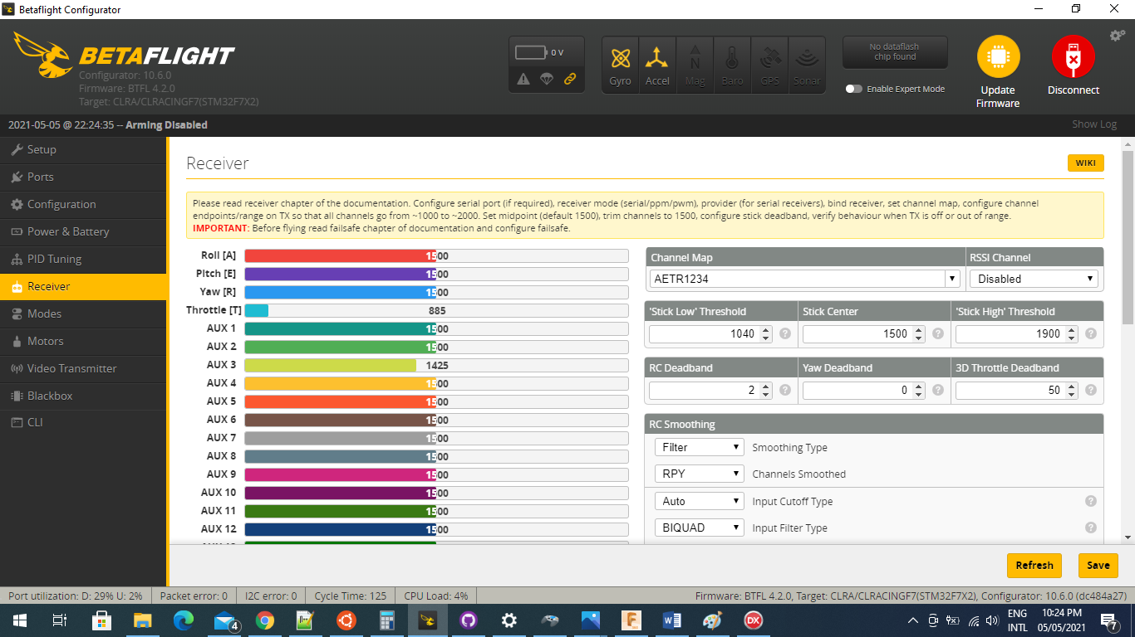

1. In the modes tab set up switches to operate the ARM and ANGLE modes. Selecting the ANGLE mode enables the rescue mode.

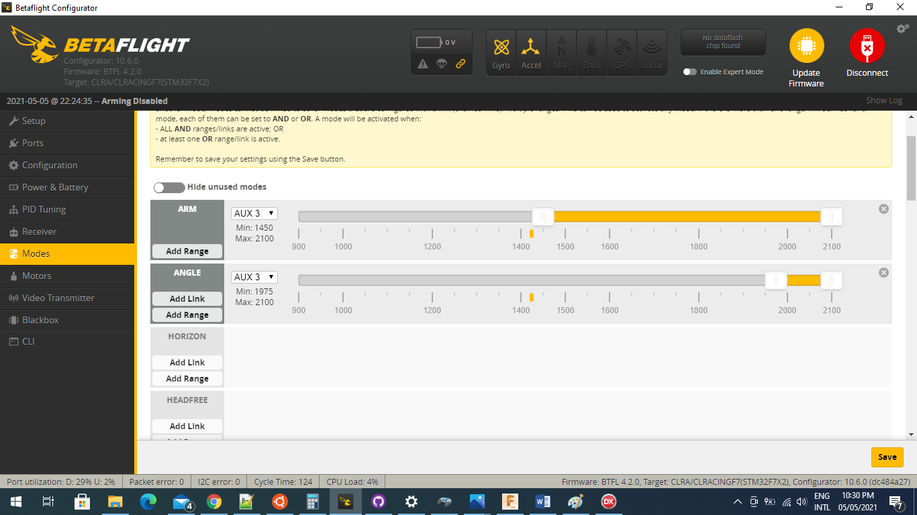

1. Setting up servos. Set the enable expert mode and click the servos tab. The servo numbering does not line up. Servo 1 is configured via Servo 2 etc shown in the pic below.

a. Change the mid point until the servo horn is in the right position. [Save]

b. Change the min and max to be equal values above and below the mid point. The range (difference between the min and max) for each servo has to be equal. In the example below I shifted the servo 2 up by 50. [Save]

c. Check the servos have full range of movement without binding. If not you will need to reduce the servo range.

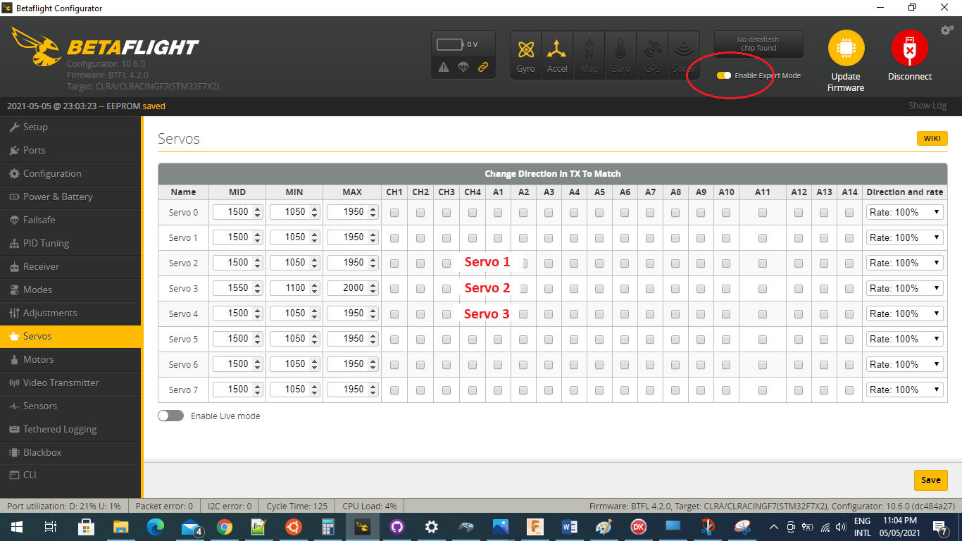

1. Backup your files once you are done. Open the CLI and type “Dump” [enter]. Select, copy and paste the entire output into a text file and save it. This is your dump file with all of your configuration. If you re-flash firmware or build another FC use your file at step 7.

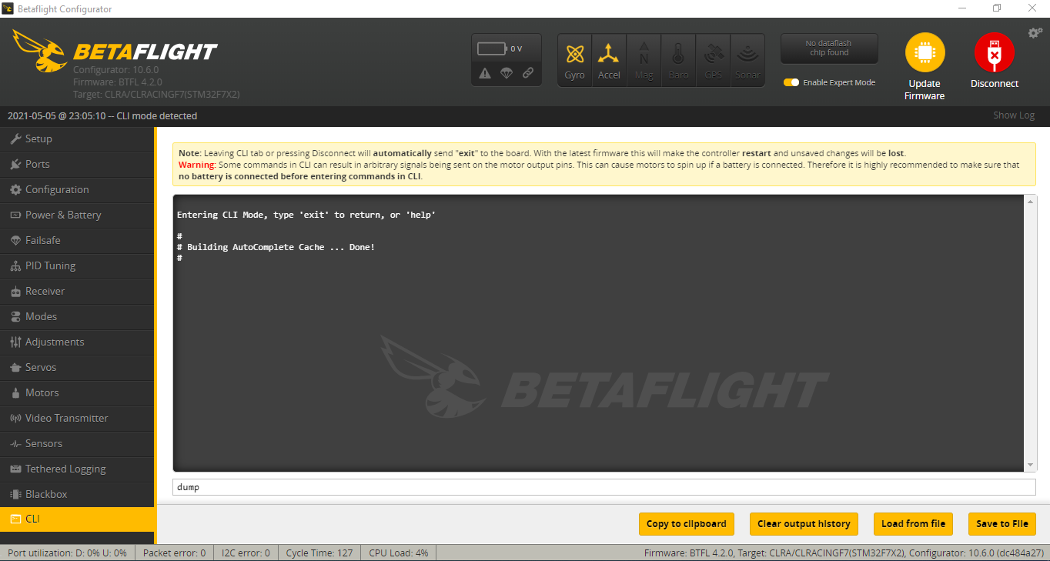

That’s it. Go fly.

PID tuning

It should be quite flyable with the PID parameters as they are. If you want to change these settings you can do it through the PID tuning tab.

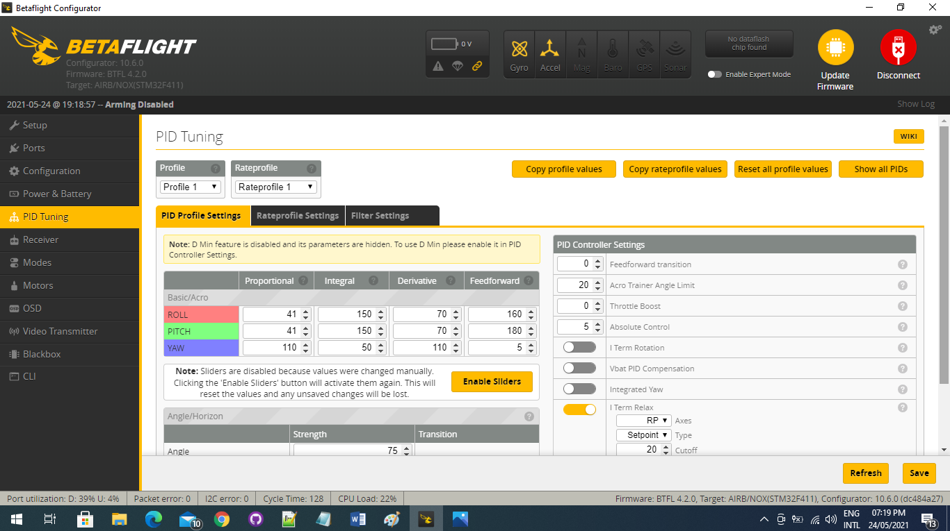

#### Ooops…. I typed Save and it won’t connect now…. Ok so this happened the very first time I made a change. Don’t know why. If this occurs you will need to use the BOOT mode and re-flash the firmware. I have downloaded and made many changes since with no issues….

There are heaps of videos and tutorials on how to re-flash using DFU mode but will need to know the boot pins which are shown below. They are really tiny and I just used some multi-meter probes to short them together. Hopefully you won’t need to.

